**ARC 5584**

**Work Order Dashboard With Costs**

ARC 5584 is a modification to the standard Open Work Order Dashboard, Advanced Planning System > View > Open Work Orders. It is located at Advanced Planning System > View > Work Order Dashboard With Costs [5584]. This dashboard has all the functionality of the Open Work Order Dashboard. Additionally, all costs on the job are pulled in, the estimated hours is pulled in differently than the open work order dashboard, and closed work orders are pulled in in a new tab.

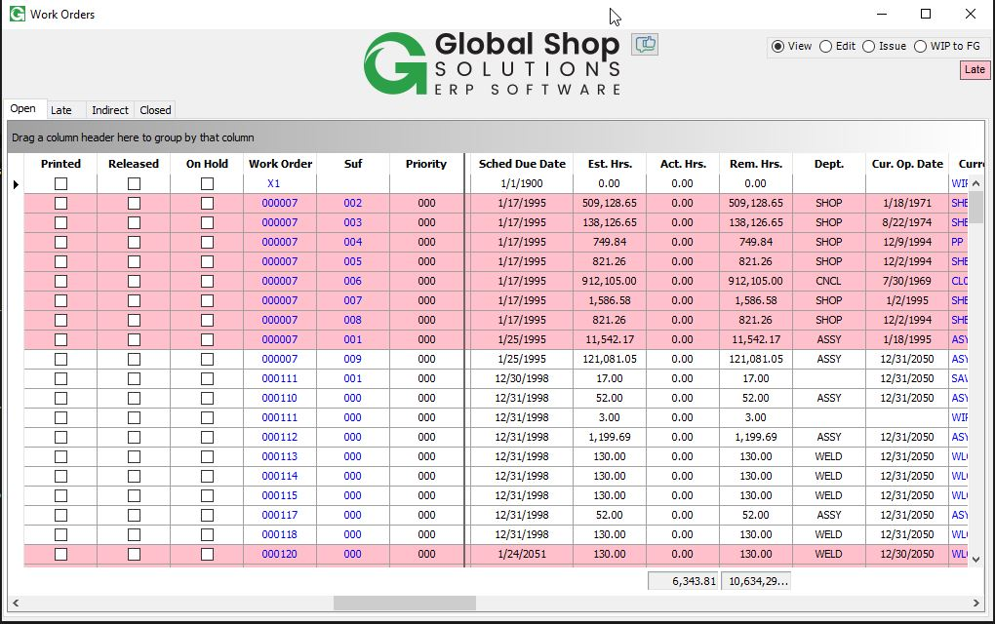

Shown above, estimated hours are now pulled in from the Global Shops Job tables instead of from APS. This means the estimated hours shown here will always match what is shown in Shop Floor Control > View > Work Orders.

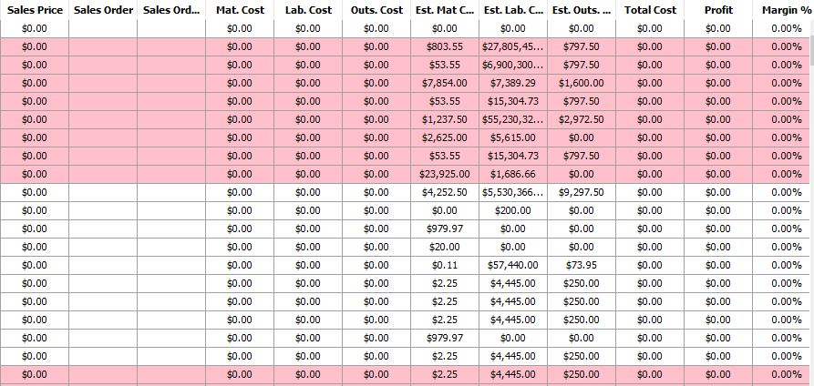

Shown above, the Sales Price, Sales Order/Line, and all costs from the work order are pulled in as well. The Total Cost column is a sum of all the costs on the work order. The Profit column is Total Cost – Sales Price. Margin % is Profit / Sales Price. Freight, Overhead, and Other cost columns are included as well, but are hidden by default.

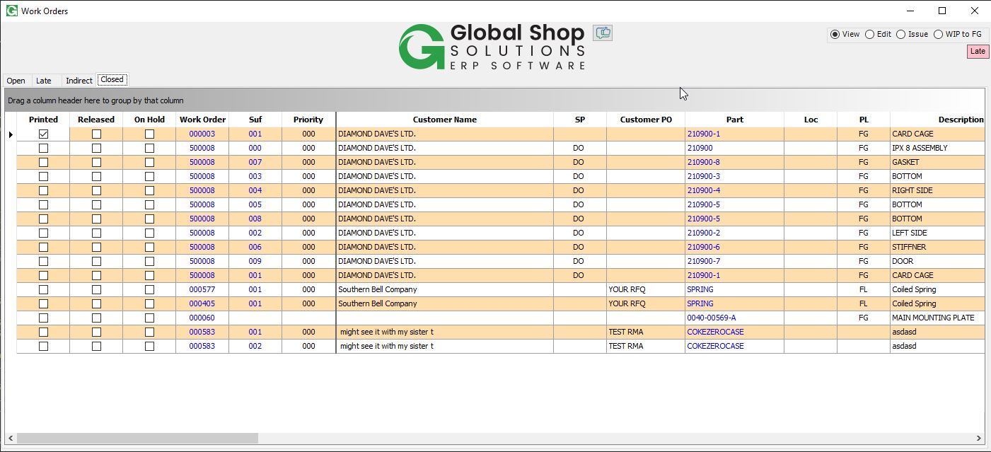

Additionally, a new tab is added for closed work orders. This will pull in the same information as the open tab, but for all closed work orders.